 

Measuring bird diversity on NDL campus

Functional specifications

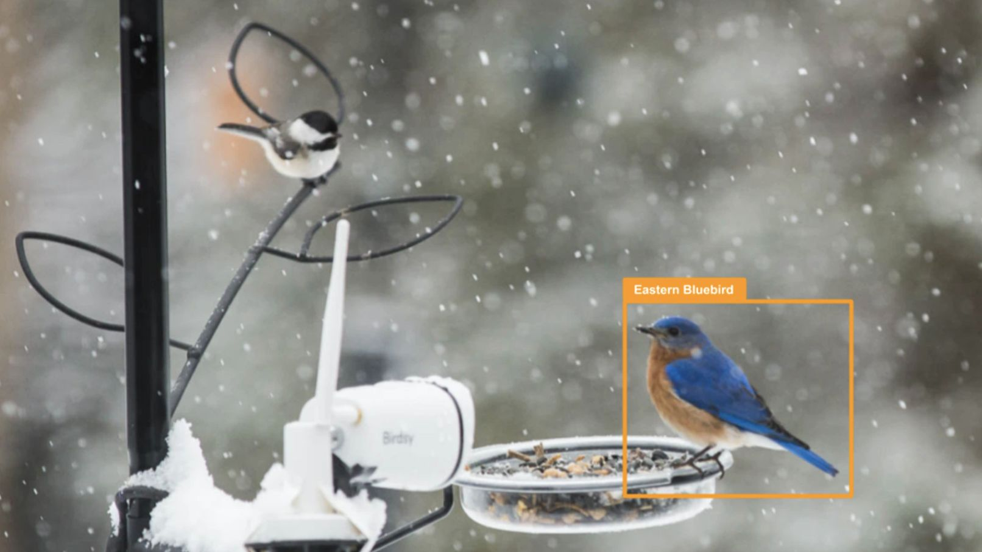

***Eileen MORGUE, Ulysse MERAD, Matthew LE BOUFFOS***

**Year 2023/2024** **Institut Supérieur d’Électronique de Paris**

**Table of contents**

**Overview** 3

Problem statement 3

Project presentation 3

Team members and contributors 3

Project scope 4

**Project requirements** 5

Bird nest boxes and feeders 5

Bird identification 9

Software 11

Data Sharing 11

Project implementation 12

Functional perimeter 13

# **Overview**

## Problem statement

It is often difficult for researchers to study the bird biodiversity at a point without the use of RFID tags to recognize the birds. Traditional techniques imply that the birds are captured in order to set RFID tags on them to later recognize them when they come back. In urban areas such as the city of Issy-les-Moulineaux, the feasibility of this is very low, and researchers lack detailed information about the bird population other than knowing which bird species can be found at Issy-les-Moulineaux after having taken pictures of some of them before. Intelligent bird feeders and bird nests are an innovative solution to tackle this issue. They can attract birds passing by and looking for food (bird feeders) but also birds who want to nest during the reproductive season (bird nest boxes). They are intelligent in such that they have cameras installed inside them or pointing at the entrance which allow for picture-taking of all bird species coming inside them. These images can then be analysed by artificial intelligence in order to identify bird species and collect relevant data to study the biodiversity at Issy-les-Moulineaux.

## Project presentation

The aim of our project is to install cameras in bird nest boxes and in bird feeders and use artificial intelligence (AI) to identify the different bird species. The data would then be analysed to offer relevant information about the biodiversity around the area of the campus of Institut Supérieur d’Electronique de Paris (ISEP) at Issy-les-Moulineaux. It would be displayed on a screen in the hall of the campus to make it educational: students would learn real facts about birds (“Did You Know?” facts) and statistics with pictures and images to make it engaging, all this information displayed on a dashboard. The finest version of the software would have a database which can be used to display information on the screen and a website. All of this involves a collaboration with the Ligue pour la Protection des Oiseaux (LPO) organization. They will be providing us with bird nest boxes and bird feeders for our school, and help us install them on our campus.

## Team members and contributors

Our project team comprises three students in their second year of the international preparatory cycle at ISEP: Eileen MORGUE, Ulysse MERAD and Matthew LE BOUFFOS.

This project has been made possible by the ISEP school administration team, following a contest for solutions to foster biodiversity in the Issy-les-Moulineaux campus, which our project won. We received funding amounting to 1 000 euros.

The help and partnership with the LPO is very crucial to the success of our project and we thank them for their advice, data sharing and ideas.

Finally, we are very grateful for the supervision and technical help provided by Mr Gilles Carpentier as well as the administrative cooperation of Mr Aymeric Sampol.

## Project scope

The overall goals and objectives of the project are to collect, analyse and share data relating to the bird frequentations on the Issy-les-Moulineaux campus over a defined time period (to be defined) to enable interested parties to evaluate the bird species diversity in this area.

Data collected within the project scope would include date and time of passage, location within the campus and identification of the bird species.

To attract the birds, we would need bird nesting boxes and bird feeders.

To collect data, we would need cameras to record their passage, which would be placed either outside (directed towards trees and nesting boxes) and/or inside the bird feeders and nesting boxes.

Accuracy of the data collected will depend on the conditions of the picture-taking: luminosity, angle, picture quality, wide data set to train our AI. As the birds are not tagged, the same bird could come in and out multiple times and therefore skew the frequentation data. The budget and time constraints could limit the overall accuracy of data collected as the training of the AI is very time and energy consuming, as well as the sorting and selection of good quality pictures to feed the AI’s data bank.

To analyse the data, we would use both artificial intelligence and possibly at the beginning human intervention to train it.

Data sharing would be done via low-energy radio transmission from the cameras to the ISEP servers. An automatic database will be implemented with all the information gathered and will be used to create a dashboard with statistics and facts about birds located in the surrounding areas of the campus.

# **Project requirements**

### Bird nest boxes and feeders

The bird nests and feeders will be provided by the Ligue pour la Protection des Oiseaux (LPO) Organisation.

**Possible examples of the bird nesting boxes**

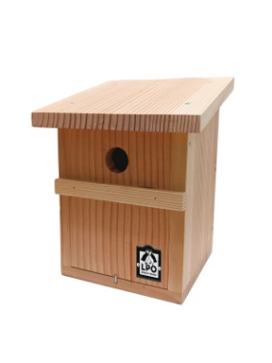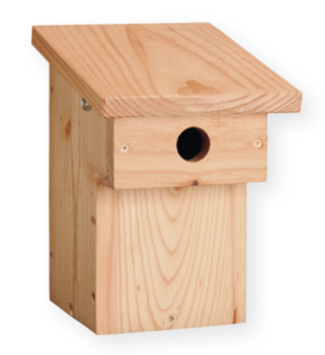

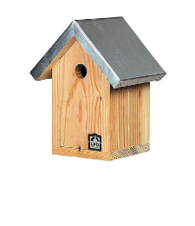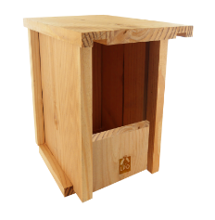

We know that we can base our bird nesting boxes on three specific nesting boxes used to attract specific bird species.

**Different types of nesting boxes**

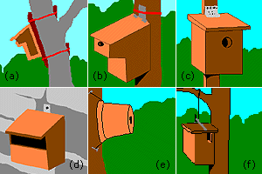

The nesting boxes of interest to our project include:

* (b) : a balcony nest box which will attract titmouses
* (c) : a letter box nest box which will attract many types of birds (titmouses, sparrows, nuthatches, and many smaller sized birds)
* (d) : semi-open nest box which will attract robins, redstarts, flycatchers

Sources:

(b) : [Nichoirs à balcon - Le Petit Catalogue - La Hulotte](https://www.lahulotte.fr/nichoirs_balcon.php)

(c) : [Nichoir Forez LPO | Boutique LPO](https://boutique.lpo.fr/produit/JO1059)

(d) : [Nichoir LPO Eco | Boutique LPO](https://boutique.lpo.fr/produit/JO0015)

The bird feeders would be made of transparent acrylic materials, optimising light exposure in order to enable maximum quality picture-taking which will offer optimal conditions for the artificial intelligence to identify the bird species.

Bird feeders should be cleaned and replenished on a weekly basis by ISEP staff.

**Example of an intelligent bird feeder used in a similar project**

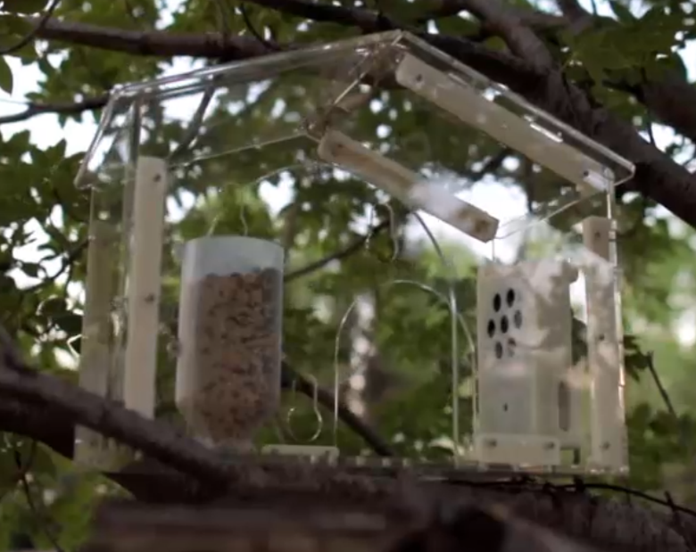

Specific details of these installations will be defined at a later date based on budgetary and time constraints.

The bird feeder can be made using the 3D printing machine available at ISEP.

### Bird identification

The main objective of our project is to automatically identify the species that have visited the nest box or feeder. This function can be described in 3 sub functions:

Bird presence detection

We should be able to detect the presence of a bird in order to trigger an image capture. The sensing technology will be chosen among several possibilities such as a PIR sensor or a pressure sensor.

**Examples of sensors**

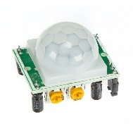

*a. Wired pressure sensor b. PIR sensor*

Image collecting

After detecting the presence of a bird, a camera with a specific lens will record a short video or a snapshot. The data saved will then be transferred to a processing device. The exact positioning of the cameras is to be defined.

**Example of a camera module**

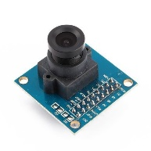

*c. Cmos camera module*

Solar battery powered cameras will be placed inside the bird feeders or nesting boxes with single-board computers to manage the information flows.

**Example of water resistant solar power bank**

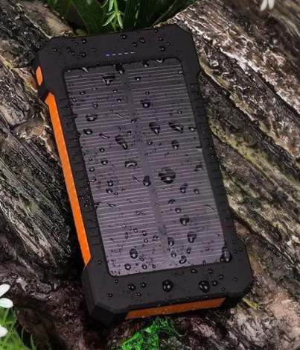

Image processing

Images will be processed automatically with internal programs inside single-board computers.

**Examples of single-board computers**

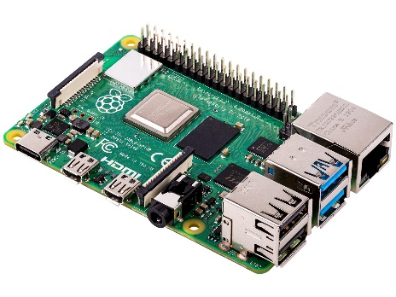 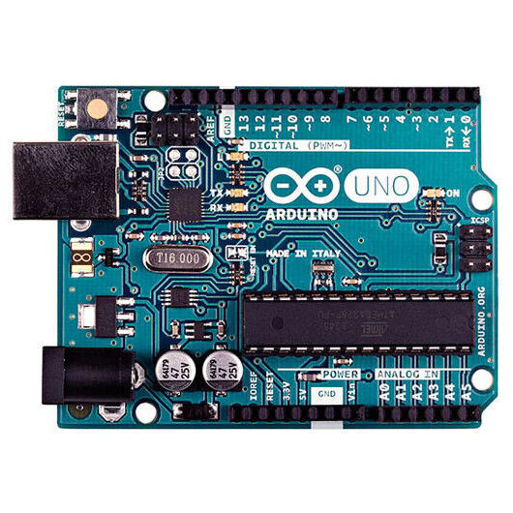

### Software

The software must be capable of realising the following tasks:

* Analysing images of birds
* Artificial intelligence using computer vision
* Database including newly collected data and imported data
* Displaying the results on a screen

### Data Sharing

The bird visits will first be registered in a table stored on a database.

Then, with this table, the ISEP servers and our program will use this data to feed our dashboard with statistics about bird visits, recent images, and facts about birds in the surrounding areas. It will be educational and updatable in real time without refreshing the page. Different statistics will be scrolled.

**Table with identified species** (to be stored on a database)

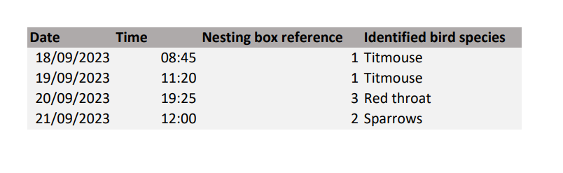

**Dashboard**

Bird species at ISEP

Most identified bird this month:

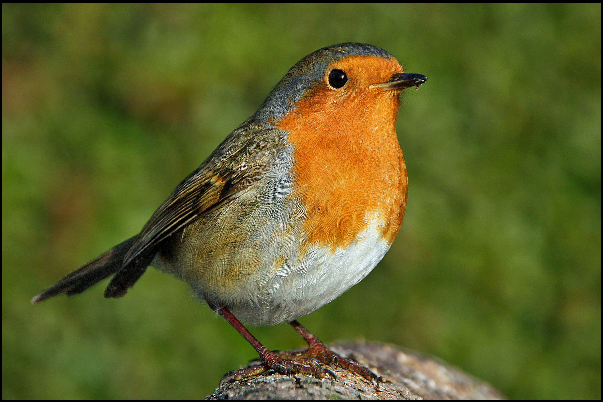

Red throat

**Did You Know?** The red throat is.. Lorem ipsum dolor sit amet, consectetur adipiscing elit. Donec id mauris iaculis, auctor lorem.

Statistics

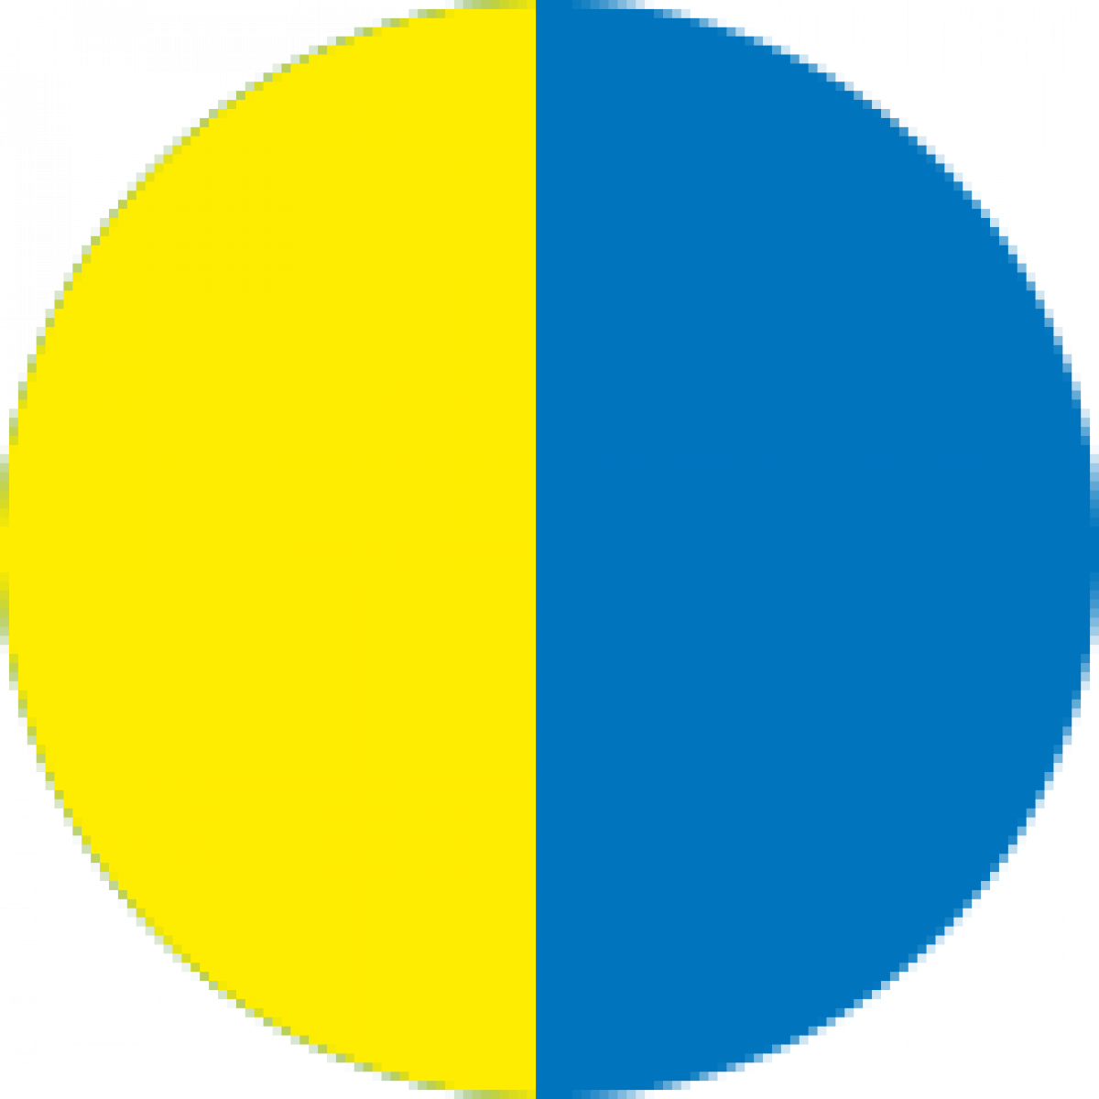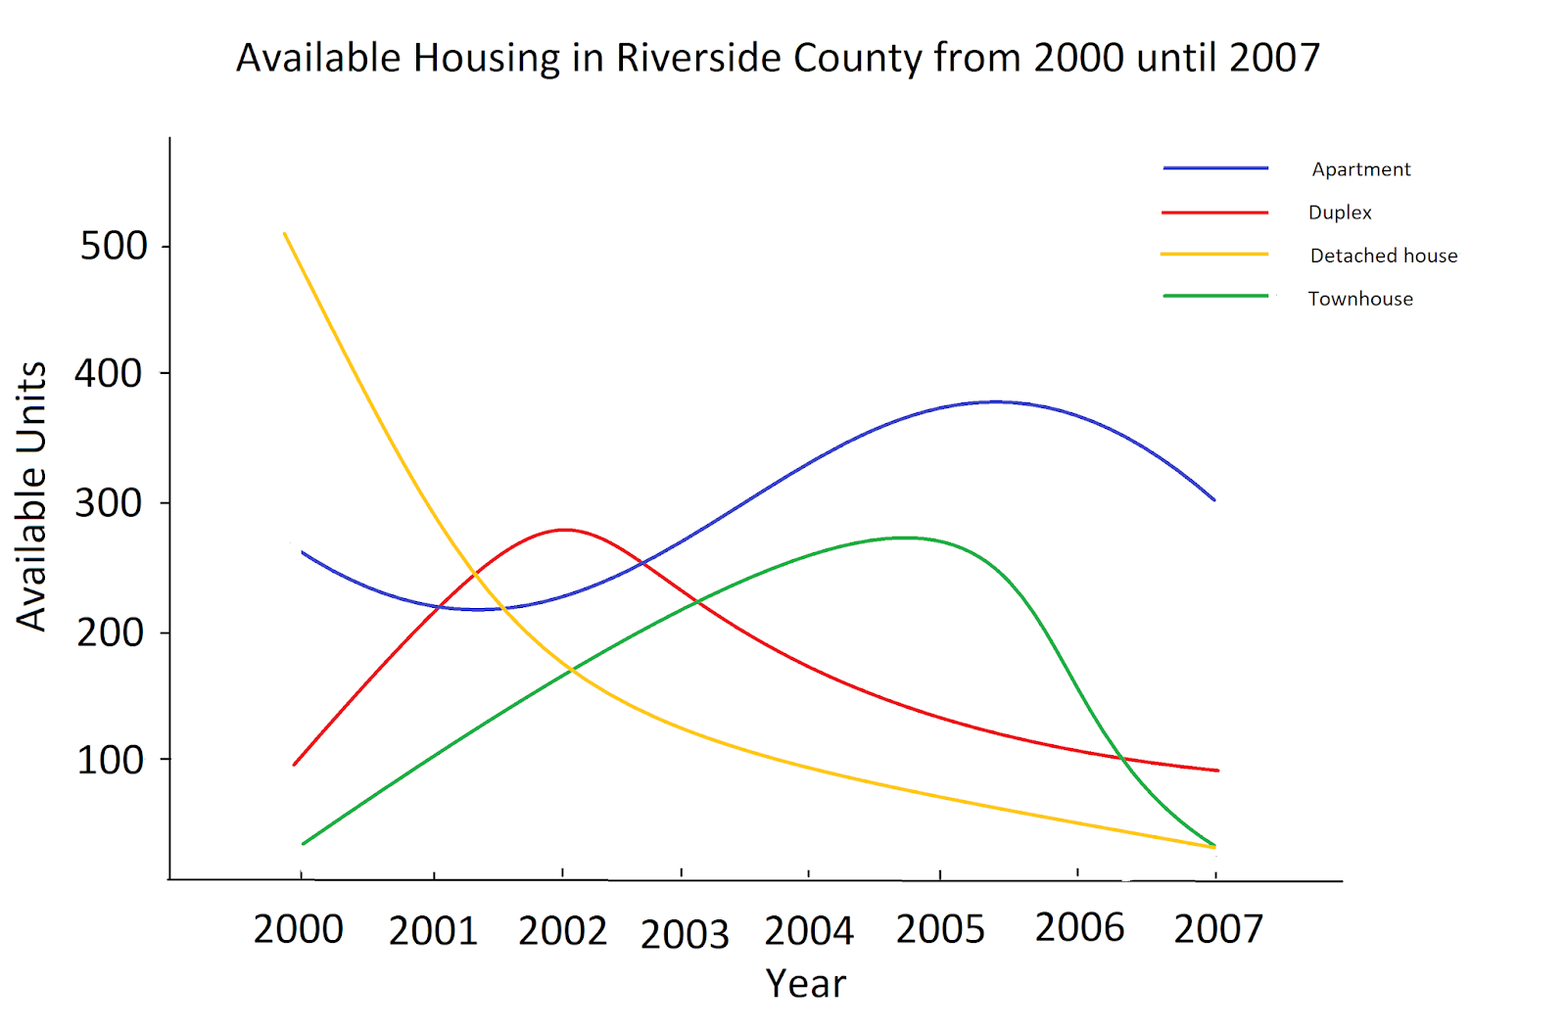

Last images taken

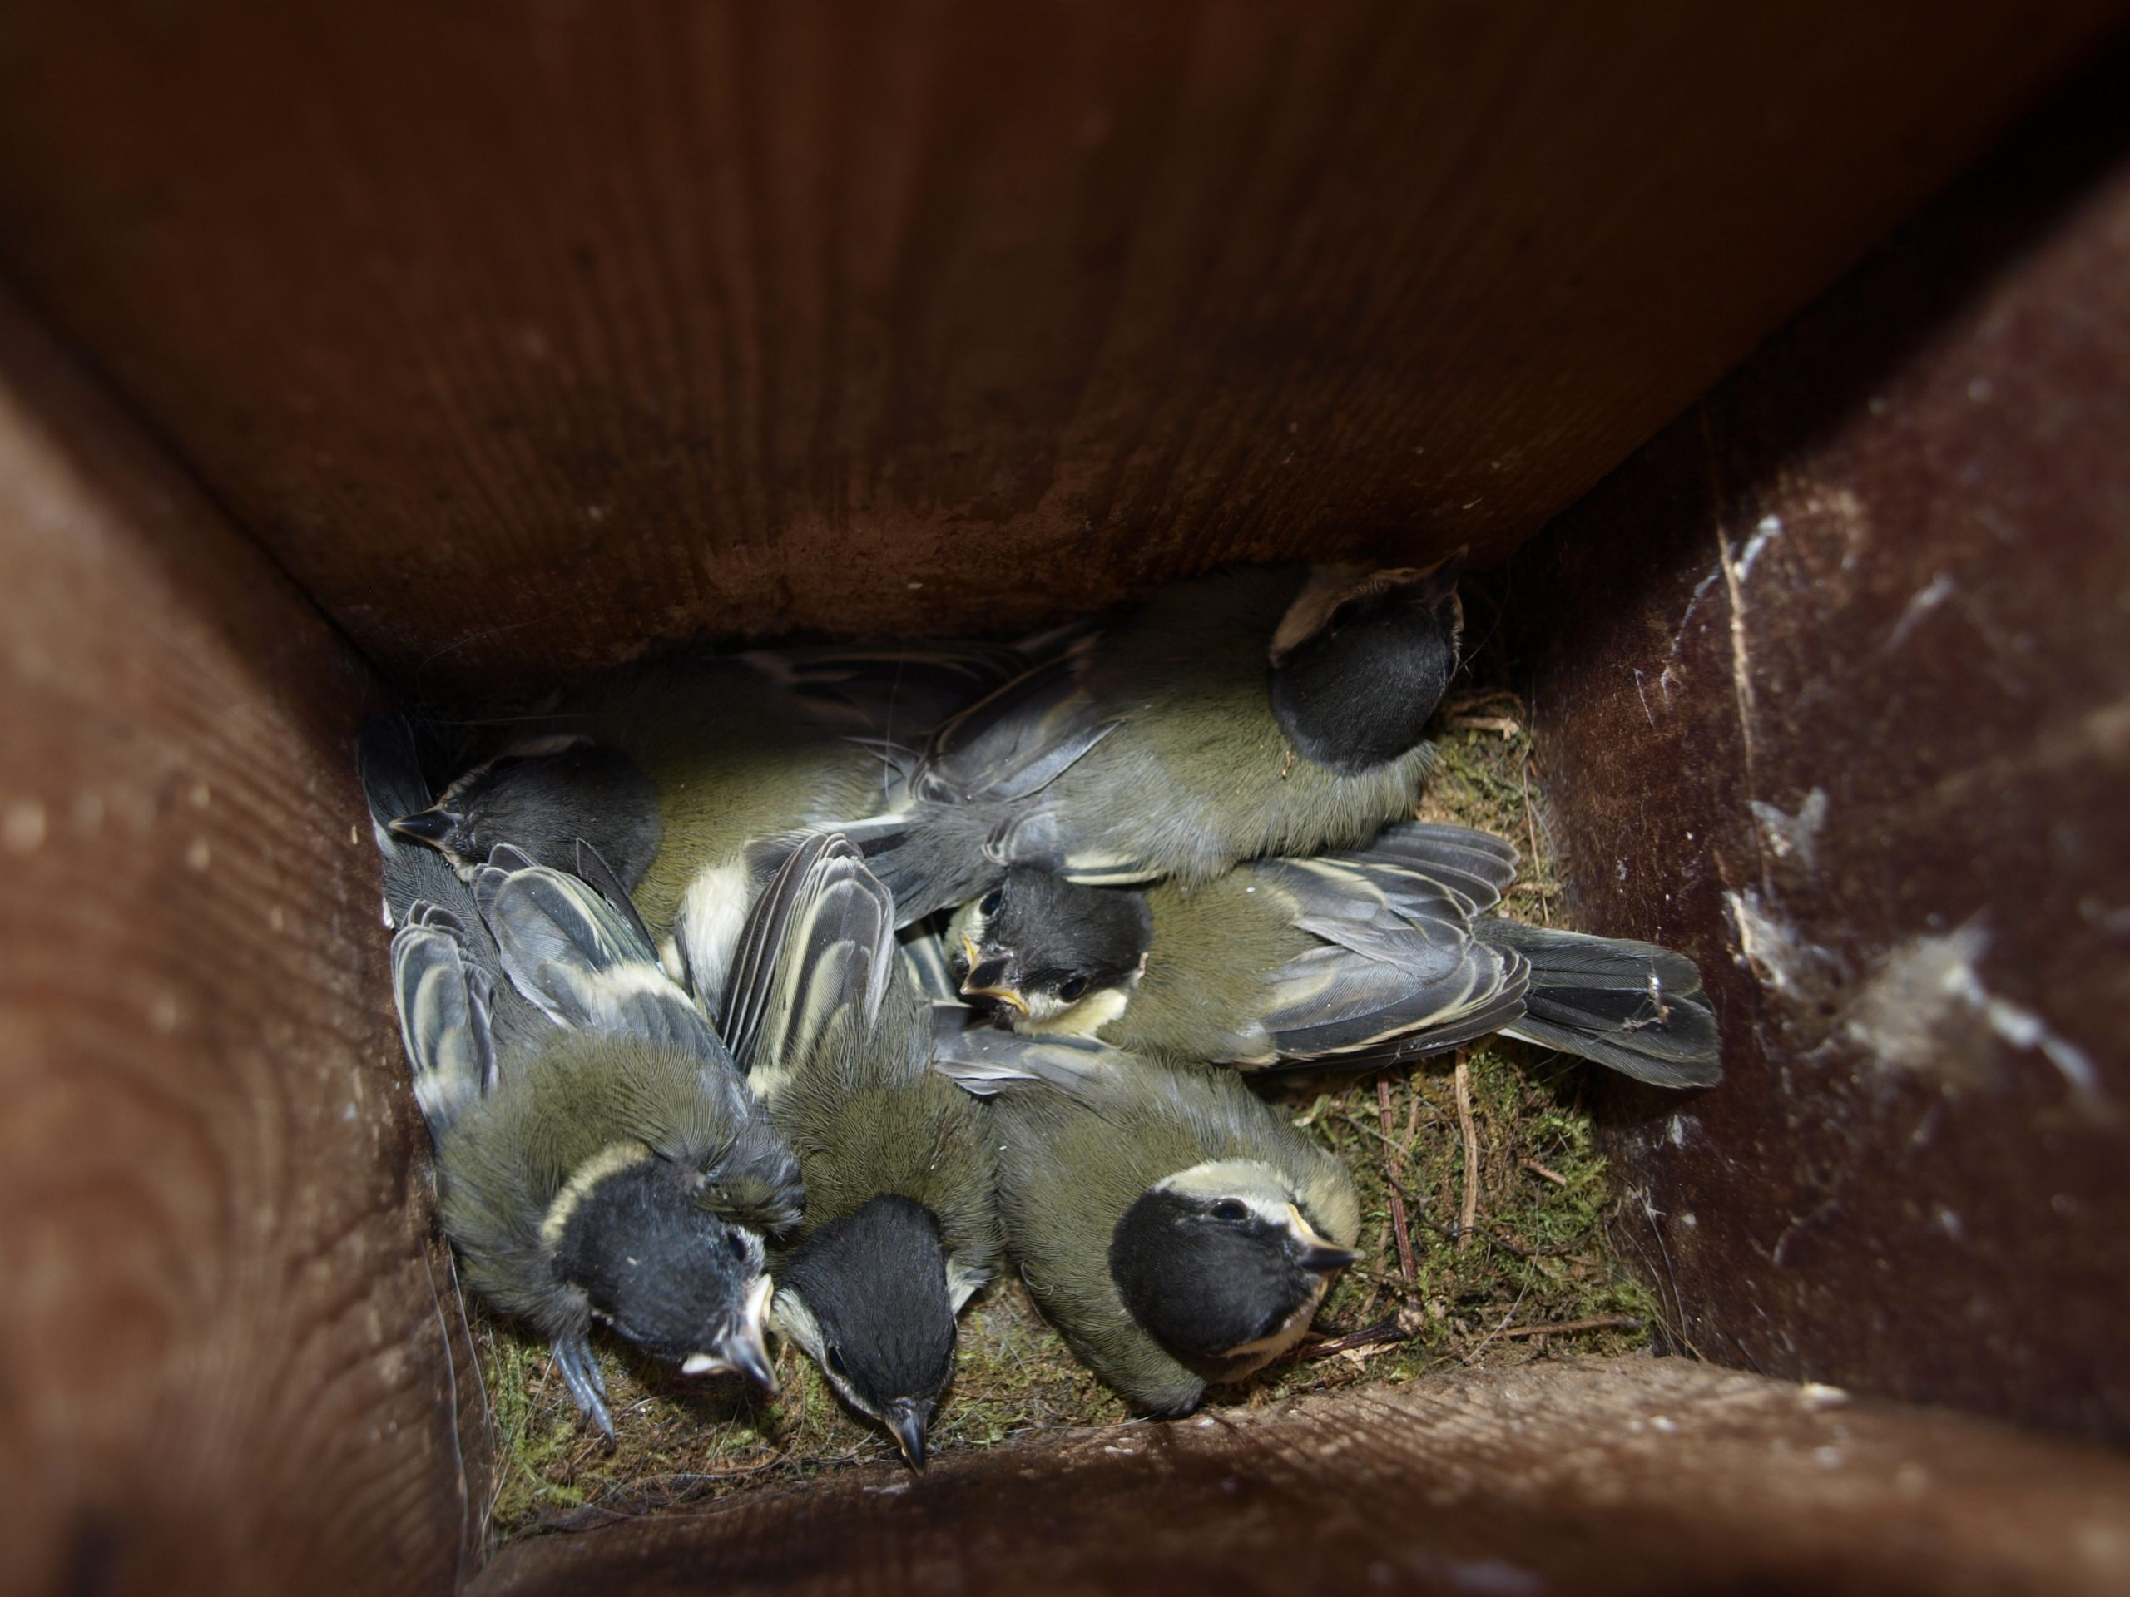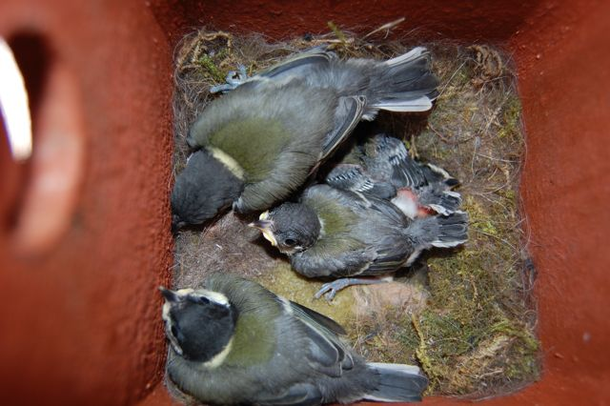

The periodicity of the dashboard will be determined.

## Project implementation

**Provisional timetable**

1) 25/09 - Autonomy (submission of the functional specifications document)

2) 02/10 - Technical specifications and breakdown per job lots

3) 09/10 - Autonomy (submission of technical specifications and job breakdown)

4) 16/10 - Object model

5) 06/11 - Coding of the object model

6) 13/11 - Coding of the object model (continuation)

7) 20/11 - Autonomy (submission of the code of the model)

8) 27/11 - Testing and finalisation

9) 04/12 - Autonomy (preparation of the defense)

10) 11/12 - Defense

## Functional perimeter

|  |  |  |
| --- | --- | --- |
| **Minimum requirement** | **Comfortable** | **Extra** |
| Identify and distinguish among 5 different bird species | Identify and distinguish among 15 bird species | Identify and distinguish among all bird species listed in Issy-les-Moulineaux (around 50) |
| Number of different bird species identified in the nest boxes per month and/or week, day | Display of these statistics on a website and on the display screen (dashboard with pie chart) | Display of the most frequent bird species with educational “Did You Know?” displays (facts and images) |
| Target recognition efficacy of 70% | Target recognition efficacy of 80% | Target recognition efficacy of 90+% |
| Monthly display of the best images taken during the month (with human-curated content) | Latest image taken in each nesting box (with no identification of the species) | Display of the latest images taken (automatically curated with name of the identified species) |
| Low-resolution images (480p) | Medium-resolution images (720p) | High-resolution images (1080p and more) |
| Simple collective data (when a bird is identified, a new line is created in a table with the date, the time, the nesting box reference, the identified bird species) | Simple collective data and image | Data management (compression of data, data saving, and other extra features to be defined) |
| Website to display data in the form of a dashboard with illustrations and predefined functions, on a screen | Automatic display of data collected on Excel sheets in the form of pie charts, graphs, etc. | Enhanced dashboard features and interactivity (to be defined) |
| 2-3 standard sized nesting boxes with bird feeders | Insertion of PVC to protect from cats, squirrels and rats | Enhancement of the capacities with improvements |

**Simplified process flow**

**Nest box and/or feeder camera**

**Image taken**

**ISEP servers**

**Sort & analysis**

**Screen/display**